Manual

Setting up the Server with MySQL

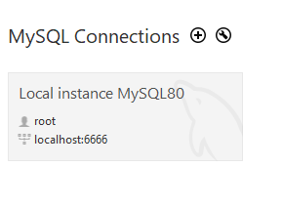

1. Open up MySQL and start up a server.
2. Open the QuizTable.sql file in the backend folder of the project.
3. 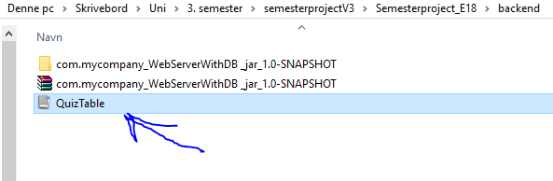Copy and paste everything that is in the QuizTable file and execute the code in your running server. That is it for the MySQL part.

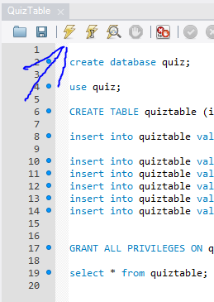

Setting up the client with Java.

1. Open up NetBeans
2. Open the project com.mycompany_WebServerWithDB _jar_1.0-SNAPSHOT that is located in the backend folder.
3. Run the project and keep NetBeans running while you do the quiz.

